**Student**

Carlos Soares – 57006

**Code Smells**

* **Long Method**:

The method presented below, although not extremely long, could clearly be refactored. The first loop to find the value of the variable 'totalWidth' should be written in a separate method.

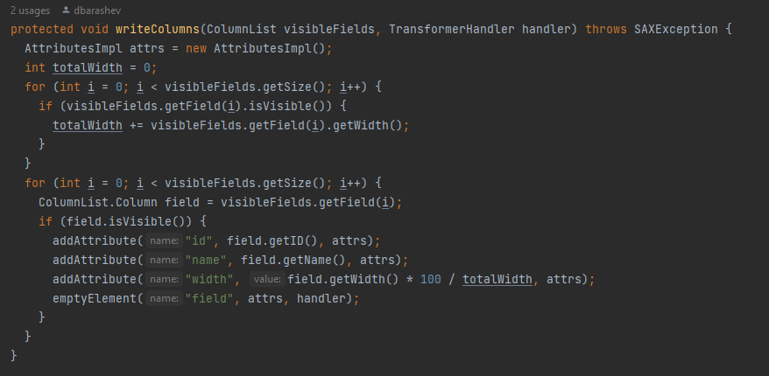

Source: org.ganttproject.impex.htmlpdf/src/main/java/XmlSerializer

The method shown below fits into the same context mentioned above - Long Method - but the reference is here since it is a method that contains 126 lines of code. It could be refactored in many ways.

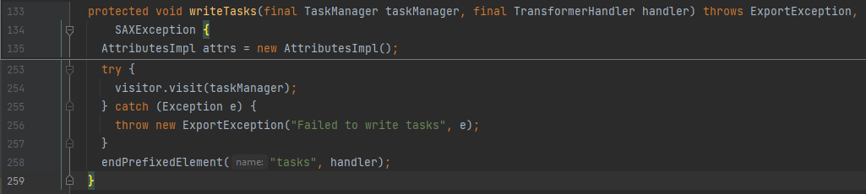

Source: org.ganttproject.impex.htmlpdf/src/main/java/XmlSerializer

* **Dead Code / Feature Envy / Speculative Generality**:

The piece of code shown below represents several types of code smells. In the GanttDaysOff Class there are 3 methods that have never been used, so it is easy to see Dead Code. It could also be argued that we may be in the presence of a case of Speculative Generality, since these methods could be written to be used later in new functionalities. Analyzing even more deeply the way in which this whole package is built, we could still put these functions in another class where they would make more sense since in this class objects and information from another class are used, namely GanttCalendar.

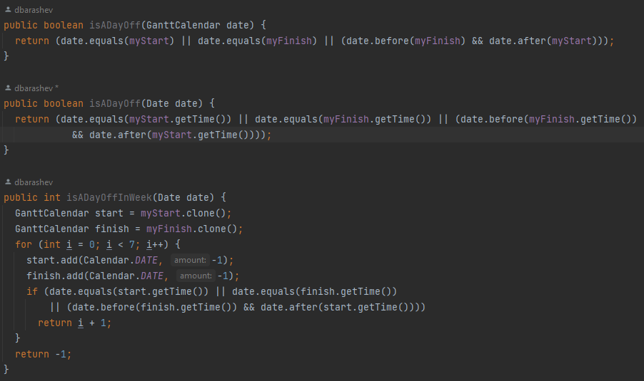

Source: biz.ganttproject.core.calendar.GanttDaysOff

* **Data Clamps**:

The next piece of code typically represents an example of Data Clamps. An object should be used here to represent the points in space, thus containing the encapsulated coordinates, not having to pass so many arguments to a function.

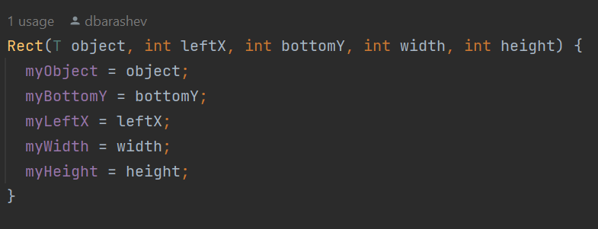

Source: biz.ganttproject.core.char.canvas.DummySpacialIndex